# File permissions in Linux

## Project description

In this scenario, I am assigned with inspecting and modifying permission for files and directories on a Linux system to ensure right user, group have the authorization based on the security policies of the company. The primary objective is to review and adjust permissions to enhance the security of the file system.

## Check file and directory details

To check the current directory, I used the pwd command. To list files and directories, including hidden ones, I used ls -a. To view detailed information such as file permissions, ownership, and timestamps, I used ls -l. The combined command ls -la provides a complete view, showing file types and permissions for all files—including hidden ones.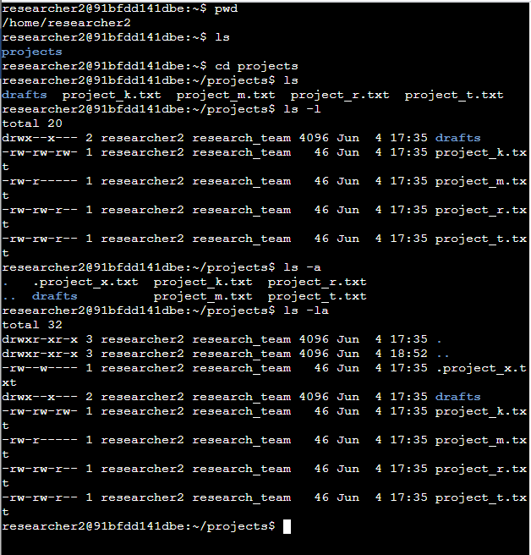

## Describe the permissions string

In the ls -la output, each file or directory has a 10-character string indicating its permissions.

* The **first character** indicates the type: d for directory or - for regular file.
* **Characters 2–4** represent permissions for the **owner** (user): r (read), w (write), x (execute), or - (no permission).
* **Characters 5–7** represent permissions for the **group**.
* **Characters 8–10** represent permissions for **others** (everyone else).  
  For example, drwxr-x--x means it is a directory where the user has full permissions, the group has read and execute, and others have execute only.

## Change file permissions

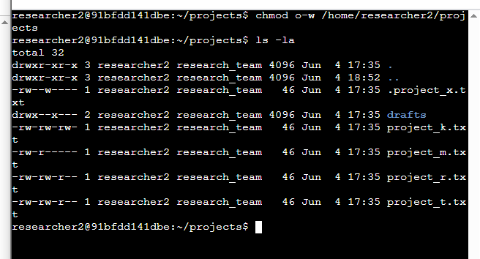

To modify file permissions, I used the chmod command. The format is chmod [who][+/-][permission] filename.

* u is for user (owner)
* g is for group
* o is for others
* + adds a permission, and - removes it

For example, chmod o-w filename.txt removes write permission from others for the specified file.

## Change file permissions on a hidden file

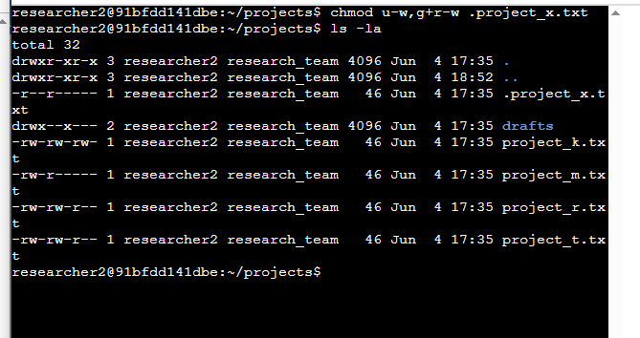

## With the command line chmod, the permission can be changed. The above picture has o after chmod which indicates for others, u is for users, g for groups. To give permission +can be used and to take away the permission – can be used like the screenshot. Change file permissions on a hidden fileChange directory permissions

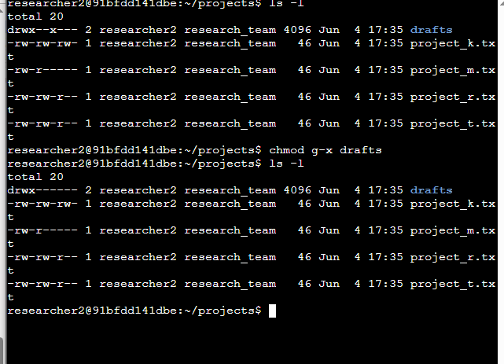

Changing permissions for a directory uses the same chmod command. This sets full access for the owner (researcher2) and no access for group and others. It ensures only the owner can access the drafts directory and its contents, as required.

## Summary

I started by reviewing file and directory permissions using ls -la, then interpreted a permissions string to understand access levels. I modified file permissions with chmod, restricted access to a hidden file, and secured a sensitive directory for a specific user. These actions demonstrate my ability to manage file permissions effectively in a Linux environment, ensuring system security and compliance with organizational policies.